CLASSIC PROOFERS

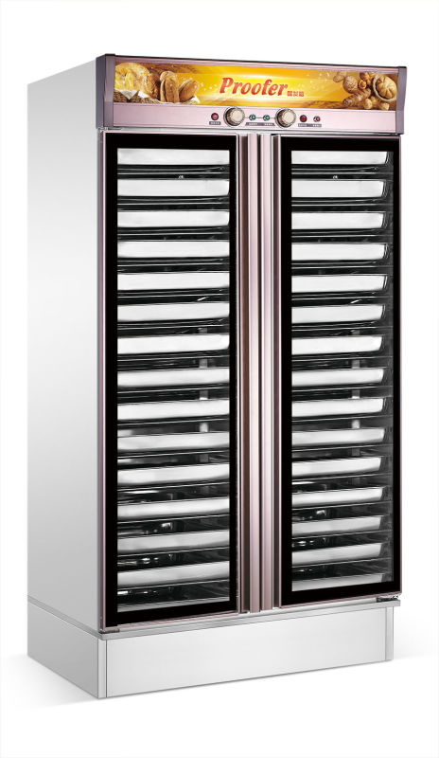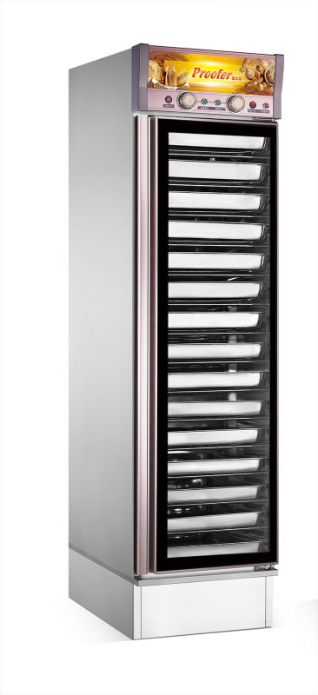

GUANGZHOU R&M MACHINERY.,LTD
Introduction
- XF series water type fermentation box electricity heat pipe by automatically adjust the heating in water, produce water vapor。Humidity at 80% - 85%, the thermostat at 35 ℃- 40 ℃, and through the design of hot air circulation to keep the temperature and humidity in the cabinet, one to form the most suitable fermentation food environment, make food fermentation process to achieve the best effect.。
- Product appearance novel, fine production, simple operation, is the bakery, cake house, pastry shop, restaurant and other indispensable equipment.

Parameters
Model | XF-12A | XF-15A | XF-24A | XF-30A
Voltage | 220V | 220V | 220V | 220V
Power | 2.5KW | 2.5KW | 2.8KW | 2.8KW
Specification | 12 trays | 15 trays | 24 trays | 30 trays
Pan size | 400*600mm | 400*600mm | 400*600mm | 400*600mm
Product size(mm) | 480*715*1570 | 480*715*1740 | 960*715*1570 | 960*715*1840

Installation Method
- Check whether the product is damaged,whether placed level, solid, do not put in damp places prone to corrosion.
- The power line behind the box is connected to a single-phase AC power switch.The double color line is a ground wire, and the copper bolt with a grounding symbol is connected with a ground wire which meets the safety requirements

Operation
- Using this proofer,you should choose the single power switch which meets the requirements of the electricity capacity ,and equip the leakage protector, and then connect the power line.
- In the bottom of the water box,it need to add about half the amount of water,so that the power can be connected, the power indicator light shows that the device has been connected to the power supply.
3.The chamber temperature switch to the required fermentation temperature.The optimal fermentation temperature is between 35℃-40℃, the humidity is between 80℃-100℃.
4.This proofer has two sets of temperature selection, the best effect is the combination of the use of the two sets` temperature.
4.1 Water temperature switch is to boil the water in the bottom , produce a lot of vapor, so the temperature and humidity to meet the requirements of food fermentation
4.2 The temperature switch is to make the water drops of the vapor condensation to heating atomization, and make the better quality of fermented food.
5. when the two sets of the fermentation temperature is switched to the needed temperature,the temperature light is on which indicate that electric heating tube is connected to the power and is starting to heat.When the chamber temperature reaches the setting value,the temperature controller will automatically cut off the power supply to stop heating.When the temperature dropped to the lower limit of setting value, the temperature controller will automatically switch on the power to keep on heating,so as to make the temperature and humidity remain in the set range.
6.When the equipment is stopped using, the power switch must be cut off to ensure the safe use of electricity.

Notice
- When the heating pipe is working to boil water, it must be kept under water, so as not to burn the heating pipe.Power on without water is forbidden.
- Fermentation temperature should not be adjusted too high, otherwise it will affect the normal fermentation of bacteria, and even cause the death of bacteria.
- Do not open the door during fermentation, so as not to affect the effect of dough fermentation, please take out the dough after 10 minutes,in case of hot steam.
- Do not be barbaric to open the door, use the appropriate strength to open the door.If necessary,use hands to overcome to the magnetic.
- Wash the fermentation tank regularly and keep it hygienic. Please use the neutral detergent. Do not use acid, alkali and other corrosive detergent.
- When the fermentation box needs to be installed or repaired, it is necessary to ask the qualified electrical maintenance personnel to install or repair. When the equipment is stopped using, the power supply should be cut off.If not using for a long time, the power supply should be cut off and the plug should be removed.
7.This machine is prohibited putting the flammable, explosive, corrosive substances, so as not to cause the accidents and unnecessary losses.
8.It is strictly prohibited to put any items except dough into the fermentation tank for fermentation or heat preservation, and it is strictly prohibited to directly use water to clean any parts of the box during cleaning.
9.When using the fermentation box,it must be used a single phase power switch which meets the power requirements , and be equipped with the leakage protector.

