Model “RMD-7L”
Food Mixing Machine Operating Guide

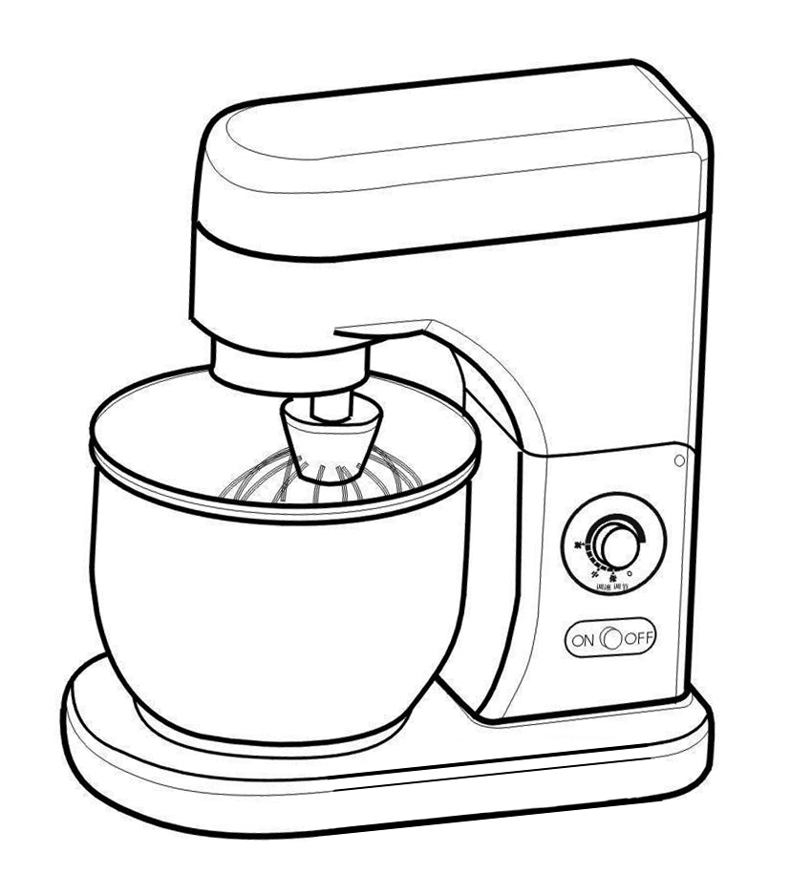
CONTENTS
Ⅰ、Machine Partly Illustration
Ⅱ、Parts List
Ⅲ、Function Features
Ⅳ、Assembly
Ⅴ、Operation
Ⅵ、Safety Caution
Ⅶ、Maintenance
Ⅷ、Troubles And Solutions
Ⅸ、Technical Specification
Ⅹ、Electronic Drawing

The product is executed standards of “JB/T 4389-1999”
Note: Please preserve the manual carefully for checking late. We are sorry that we will not give you any information if any design changed of the machine.

Cover Letter
Dear Customers：
Thank you for selecting our Model “RMD-7L” food mixing machine. The machine is our company new developed product with update technology. It can mix dough, dumping stuffing, circumrotate egg and cream mixing. The constant-torque and infinitely variable speed technologies have been used in the machine. You can select any rotating speed from 131 rpm to 1000 rpm for different load. There is overload protect installation in the newest machine. It is good-looking, easy and safely operating. There are wide application fields. Also, this machine works efficiently and smoothly. It is an excellent helper to make cake and dough food in western food kitchen, bread-room, bar, restaurant and family personal kitchen etc.
Thanks & Regards

President
1、Machine Partly Illustration

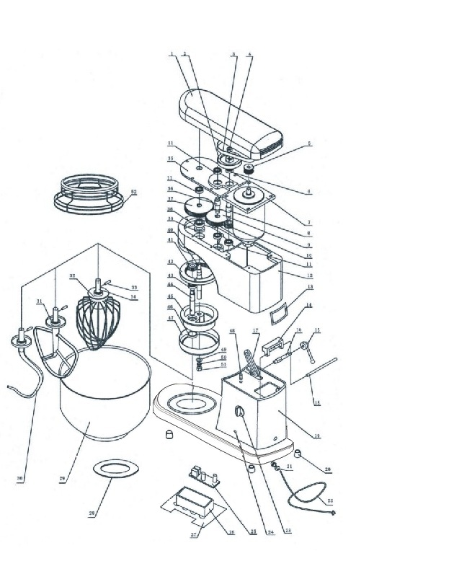
(Drawing 1)
2、Parts Lists (table 1)
Item | Part Number | Description | Remark
1 | 05010 | Top Cover
2 | 05020 | Large Pulley
3 | 05030 | Belt
4 | 05040 | Nut
5 | 05050 | Small Pulley
6 | 05060 | Oil Bearing | Φ22×Φ10×6
7 | 05070 | Motor
8 | 05080 | Axle Of Belt Wheel
9 | 05090 | Gear wheels
10 | 05100 | Active Gear
11 | 05110 | Oil Bearing | Φ19×Φ8×6
12 | 05120 | Box
13 | 05130 | Name Plate
14 | 05140 | Overturn Seat
15 | 05150 | Handle
16 | 05160 | Closed shaft
17 | 05170 | Closed seat
18 | 05180 | Axle Pin
19 | 05190 | Base Plane
20 | 05200 | Rubber Mat | 4pcs
21 | 05210 | Electric Cable Plug
22 | 05220 | Electric Wire | 3×0.75㎜×2m
23 | 05230 | Speed Adjusting Button
24 | 05240 | Indicator Switch
25 | 05250 | Circuit Plate
26 | 05260 | Electric Box
Item | Part Number | Description | Remark
27 | 05270 | Bottom
28 | 05280 | Pad
29 | 05290 | Mixing bucket
30 | 05300 | Hook stirrer | Only for select
31 | 05310 | Racket-shaped stirrer | Only for select
32 | 05320 | Net-shaped stirrer
33 | 05330 | Pin
34 | 05340 | Connecting shaft
35 | 05350 | Positioning plate
36 | 05360 | Gearwheels
37 | 05370 | Large Gear
38 | 05380 | 6001Bearing
39 | 05390 | Seal | Φ12×Φ25×10
40 | 05400 | Central axis
41 | 05410 | Planetary Gear
42 | 05420 | Inner Gear
43 | 05430 | 6901Bearing | 2pcs
44 | 05440 | Mixing Axle
45 | 05450 | Main Axle Cover
46 | 05460 | Seal | Φ20×Φ25×7
47 | 05470 | Anti-oil-cap
48 | 05480 | Orientation Pin
49 | 05490 | Flat pad
50 | 05500 | Spring Cushion
51 | 05510 | Nut
Note: The Remarks column does not indicate the number of parts is one.

3、Function Features
As the mixer has used infinitely variable speed and planetary gear technologies, so it has a large speed range, easily operated. It can mix dough, dumpling stuffing, circumrotate eggs and cream mixing. It is very good for using in western food kitchen, bread room, eating house, restaurant and home.
4、Assembly
4.1 It is better putting the mixer on horizontal & stable plan. The best height of the plane is between 650㎜--750㎜. Please leave 150㎜space distance at front and rear. Leave 300㎜ at left and right.
4.2 The power must use a separating electronic socket with fuse device protecting rated.
4.3 The electronic socket must have earth-connection.
4.4 It is necessary to be operated by qualified electrician when assemble all the electrical parts.
5、Operation
Operating parts are in drawing 2.
5.1 Stirrer assembly and disassembly
Please stop the machine work and press the head of the machine by your right hand, then the left hand pull out in the Figure 2 while your right hand softly press the head please in order to make it automatically lift 45 degrees. Now release the left handle, and right hand raised the head about 45 degrees, finally the handle will automatically bounce.
Along a key of the mixer axle, insert the mixing agitator "c" to a hole in axle of mixer "b" lightly. Turning left to “stop point" to assemble the mixing agitator. Reverse the process to disassemble the mixing agitator.
Press the head of the cutting machine by your right hand, and please see the auto-lock when the head is in the work place, then the handle will automatically bounce.
The state of mixer head raising (Drawing 2)

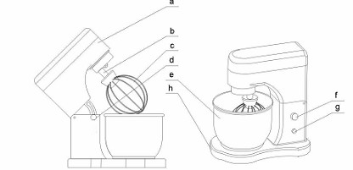

(Drawing 2)
- Head of mixer b. Axle of mixer c. Agitator of mixer d. Handle
e. Bowl of mixing f. Speed Adjusting g. Switch. h. Basement

5.2 Select a suitable mixing agitator
There are three kinds of shape mixing agitator for selecting.
5.2.1 Hook stirrer(No.30)is for sticky and large things , such as dough etc.
5.2.2 Racket-shaped stirrer (No.31) is for bulking things, such as meat dumpling stuffing etc.
5.2. Net-shaped stirrer (No.32) is for unstuck or just a little stockiest things, such as eggs and cream.
Note: Don't select the wrong mixing agitator otherwise the machine will not be working, even will be damaged. Please accord to the viscidity of mixing thing to make a choice.
5.3 How to assemble and disassemble the bowl
Shutting off the machine, rising the head of the mixer to position "a", hold the stainless steel body tightly with your hands, follow the hand revolve to halt point, it should be fixed. Reverse the process to disassemble the bowl. By 5.1 to the
over 10minutes each time. The machine weight of flour the limit gear is just gear 1.Others can be used gear 2 limited.
5.4 Adjust the speed
Setting the speed button to "O" position(Drawing3-1), connect the electronic power, indicator light will be on, starting the machine and clockwise direction turn the button to adjust the speed according to property of mixing thing and the mixing agitator. The speed will be increased while the button turns from left to right.
When the arrow is on the top of middle (Drawing3-2), the mixer is low speed, it is good for dough.
When the arrow is on the top of middle (Drawing3-3) that the mixer is middle speed, it is good for meat dumpling stuffing.
When the arrow is on the top-right (Drawing3-4), the mixer is high speed, it is good for eggs.
This mixer is infinitely variable speed, user can choice best speed for your job.
Rotary direction from shaft out: The rotary direction of main shaft cover is clockwise, and rotary direction of mix shaft is anticlockwise.
Note: Don't against the speed choice law above. Otherwise the machine working efficiency will be reduced. Sometimes even broken, don't operate the machine

5.5 How to adjust the height of mixing agitator
Sometimes, the interval between bottoms of mixing agitator to bowl is too close and sometimes it is too big, adjusting the height of mixing agitator is necessary. You can operate by the
Following steps(drawing4).
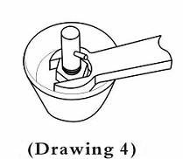
a. Shut off the power source at first.
b. Used a wrench to release the nut of mixing agitator.
5.5. Adjust the interval, tighten up the nut.
5.6 Each job is finished, please return back the speed button to "O" position, and then turn off the machine, cut off the power.
6、Safety Caution
6.1 Remove the machine, cut the power at first. When disassemble the mixing agitator, mixing bowl machine must be turn off.
6.2 Don't use your wet fingers to operate the machine.
6.3 Don't water the machine, don’t put it in water.
6.4 If any part is broken or it is under an unmoral condition must shut off the machine, waiting to fix by technician.
6.5 Don't put fingers in bowl, while it is working.
6.6 Underage persons please keep away from the machine.
6.7 When the machine is working or the head is rising, the handle "d" must be automatically bounced.
6.8 When the head is rising, don't put any finger on link parts between the head and stand of machine for injury.

6.9 There is a earth contact terminal (mark in back of stands, please keep head of mixer down, then the handle will automatically bounce.
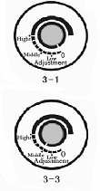
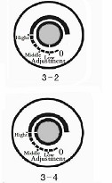

(Drawing3)

7、Maintenance
7.1 It is food machine, so all parts that contact with food have to remove and wash clear every day after working. Don’t use some kind of cleanser that may be harmful to persons.
7.2 Don't turn on the machine if there is nothing in bowl.
7.3When mixing agitators beat bowl.stop working immediately, and correct the space or change the agitator or bowl if necessary.
7.4 When you use the machine more than one year, please contact with the supplier or qualified agent for maintenance.

8、Troubles & Solutions
Troubles | Reasons | Solutions
Turn on, but don't working | - No power  - The speed button isn't on "O" position | - Check the power plug  - Turn the button to "O" then start the machine.
Temperature of motor is increase &speed is decrease | - Voltage is too low  - Load is too large.  - Mixing head isn't suitable  - Belt is wear out | - Check electronically parts.  - Reduce mixing volume  - Choice suitable agitator.  - Change a new belt.

Suddenly stop working | - Load is too large.  - Voltage undulates too large.  - Fuse is broken.  - Continue working too long. | - Reduce mixing Volume (table 2)  - Check the voltage  - Change a new Fuse  - Waiting a few minutes
Speed button is not working | - The speed button is loosening.  - The button is broken after long time work. | - Tighten up the screw of speed button.  - Make a call for maintenance.
Mixing head beat the barrel | The head position is incorrect. | Adjust the item5.5
9、Technical Specification (table 2)
Description | Unit | Parameter
Capacity of mixing barrel | L | 7
Speed of mixing mandrel | r/min | Revolution:40~260  Rotation:131~852
Rated voltage | V | 220
Rated Frequency | Hz | 50
Input Power | W | 350
Electric current | A | 1.5
Max. eggs weight | g | 500
Max dough mixing | g | 500(dry flour)
Working environment |  | indoors
Net weight | kg | 27
Dimension | mm | 370×240×410

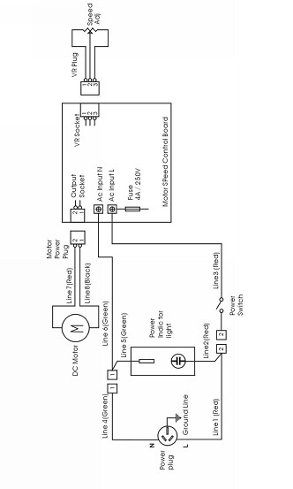
10、Electronic Drawing

